Monthly Board Meeting
March 18th, 2025
Zoom: https://mcphs.zoom.us/j/95581320152?pwd=enBTTXBwbzdaeEhSOXZUWEhZZU9hdz09

3-5 pm
 | 1/21/26 | 2/18/26 | 3/18/26 | 4/15/26 | 26-May | 26-Jun | 26-Jul | 26-Aug | 26-Sep | 26-Oct | 26-Nov | 26-Dec
Amanda Morrill** | X | X | X
Chris Lopez** | X | X | X | X
John Moro** | X | X | X | X
Katelyn Comeau** | X | X | X
Laura Daly** | X |  | X | X
Megan Hill* | X | X | X
Sean Buckley* | X | X
Elizabeth Sargent
Helen Jung* | X | X
Arlene Wiseman* | X | X | X
Brian Brooks** | X | X |  | X
Margaret Clifford* | X | X | X | X
Sean Posner |  | X
Megan Goodrich |  | X | X
Ed Wolf |  |  | X
Mireille  Ben Andiolo |  |  | X | X
Mary Grossi |  |  | X | X
Alexander Cole |  |  | X | X

Board Members
Executive Committee: Amanda Morrill (President), Katelyn Comeau (President- Elect), Chris Lopez (President Emeritus), John Moro (Vice President), Laura Daly (Treasurer), Brian Brooks(Secretary)
Board of Directors: Sean Buckley, Helen Jung, Arlene Wiseman, Margaret Clifford, Meghan Hill (Student)
Lobbyist: Beth Sargent

Item | Discussion Items | Member
Approval of minutes | - March minutes  - Minutes approved | Amanda
Membership Committee | - Membership #’s  - Down 1 pharmacist  - Up 1 Student  - Down 1 Pharmacy Technician  - No changes to corporate membership  - Up one associate member  - Net same as last month of 81  - Corporate Membership  - No new news  - Still waiting on news from CSL, Seqirus and Madrigal Pharmaceuticals.  - Is Pfizer a potential member?  - John to reach out to potential contact. | Katelyn  Meghan
 | 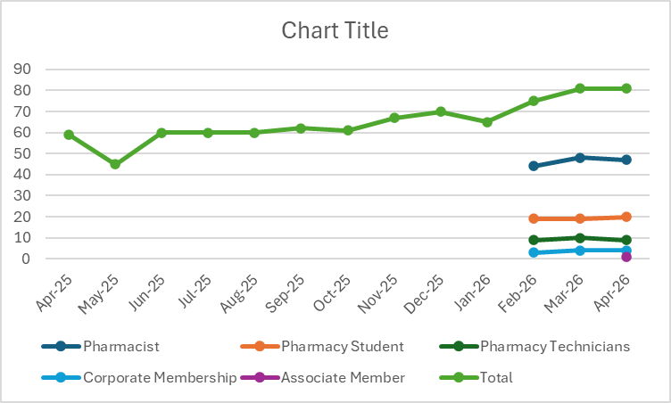
Communications Committee | - Website management – NASPA LLC  - Newsletter Q2  - April  - Most of the content is finalized, waiting on Pharmacist spotlight and Legislative update  - Just waiting on headshot from Lawrence Sweeney  - Social Media – no update  - No major update, but meet with NASPA regularly.  - Trisha, our webmaster, has posted quite a few ‘call to action’ communications. | John  Peg  Brian
Education Committee | - 2026 CE  - Fall conference – Sept 12th at Bedford Event Center  - Speakers: Jason Lancaster (lipid management), Alexa Carlson (menopause), Andrew Orr-Skirvin (Hem Onc/curative therapies), ?LouAnn Giangreco? (value of pharmacists in the community) plus 1 hour of law/billing etc.  - Next steps: Reach out to CPA (Amanda) for credits. Create an advertisement once speakers are confirmed.  - Food- same as last year.  - Can membership committee get more pens/swag please?  - If anyone has a new suggestion for a law speaker please let a committee member know!  - Topic of interest would be upcoming law changes, and guidance on passing inspection.  - Brian to re-order pens  - Joint CE with NHSHP (June or November) – waiting for speaker confirmation.  - More news to come  - Online live  - Amanda is waiting to hear back from Krystalynn.  - 1 law (Amanda will ask Krystal from NASPA)  - Virtual library (try to test build from live CEs) | Amanda  Laura  Sean  Arlene
Legislative Committee | - Legislative Updates  - Board of Pharmacy Meeting  - Standard of Care\/Definition of Pharmacy Practice  - SB 504- Heard in House E,D&A today!  - Hearing was at 1 today  - Medical society objected to “prescribe”, “diagnose and treat”. They had questions about boundaries, or guardrails.  - Katelyn testified for HB 1249 for prescribing medical supplies. Hoping that SB504 would pass, but willing to accept if not.  - The Rural Health Transformation Program, established through H.R. 1  - Federal grant program, allocated funds that states could apply for funds for improving rural health.  - ‘Go North’ DHHS program using these funds.  - Chris to update with some details  - BOP meeting  - John attended, no real updates. Very short, rushed discussion.  - Legislative day- no update | Amanda/Beth
Scholarship and Awards Committee | - Scholarship Foundation  - No update yet  - Awards | Katelyn/Brian
APhA | - House of Delegates – Update in May | Amanda
Public/ Population Health Committee | - Tobacco Free NH (TFNH)  - No updates  - Reproductive Equity Now  - Katelyn and Chris suggest a proposal to alter the BOP rules to make it realistic to prescribe hormonal contraceptive. | Chris/Amanda/Arlene
Other | - See above  - Bob Stout emailed NHPA could get access to licensee’s from BOP. The previous director of OPLC was against this action. Current Director of OPLC may be more receptive to providing this list.  - John / Katelyn to have update next meeting.

Next Meeting: May 20th at 3pm via Zoom
Location: Zoom

